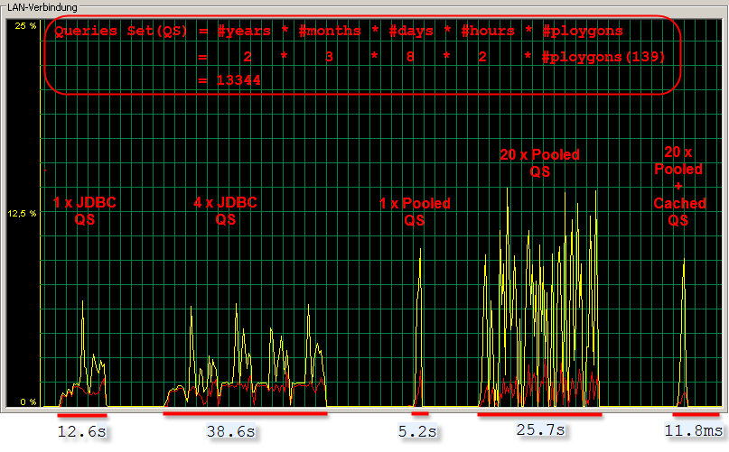

Time for Oracle Connection
 | JDBC | Connection Pool | Connection Pool+Local Cache
#QS | time (ms) | time (ms) | time (ms)
1 | 12625 | 4985 | 4609
2 | 9547 | 2328 | 734
3 | 8969 | 2219 | 704
4 | 8656 | 1906 | 687
5 | 8594 | 1891 | 531
6 | 8433 | 1906 | 641
7 | 8256 | 1765 | 516
8 | 8156 | 1485 | 390
9 | 8357 | 1719 | 688
10 | 8369 | 1734 | 531
Total | 89962 | 21938 | 10031
avg. | 8593 | 1884 | 602

